PERSONAL INFORMATION | Ada Rudi
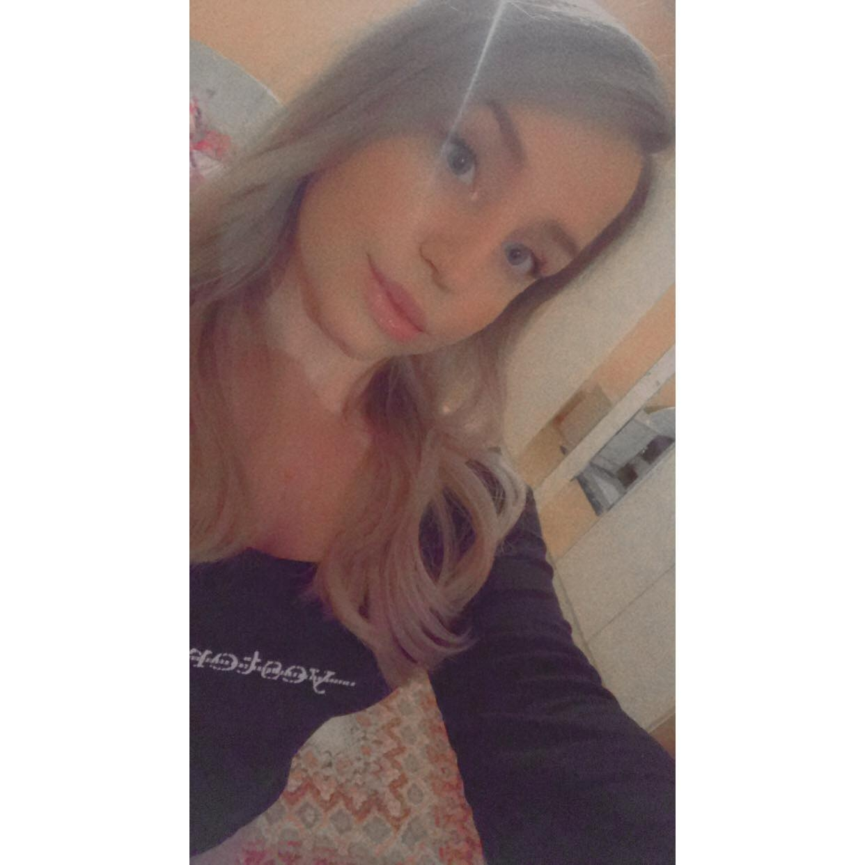 |   Sylejman Lleshi street,Gjakova/Kosovo
 |  mobile 044430645

adaswiss@hotmail.com
 | Sex Female | Date of birth 08.18.1999 | Nationality Albanian

I have studied COMPUTER SCIENCE AND ENGINEERING at UBT Prishtine.In the third year of studies I had chose n specialization about Cyber Security.
JOB APPLIED FOR
POSITION
PREFERRED JOB
STUDIES APPLIED FOR

EDUCATION AND TRAINING

Replace with dates (from - to)
  Gjimnazi “Hajdar Dushi “ high school from 2014-2017
  “Yll Morina” elementary school from 2010-2014
  JAVA FOUNDAMENTAL COURSE at CreativeEducationpr with Erroll Gorci teacher from 11.01.2018-01.01.2019

PERSONAL SKILLS

Mother tongue(s) | Albanian
Other language(s) | UNDERSTANDING 10,9 |  | SPEAKING 10,9 |  | WRITING 10,7
Other language(s) | Listening 10,9 | Reading 10,7 | Spoken interaction | Spoken production
 | ENGLISH
 | SPANISH
Levels: A1/2: Basic user - B1/2: Independent user - C1/2 Proficient user
Common European Framework of Reference for Languages

Communication skills | Communication is very important for a programmer.I am ready to cooperate with others and to work overtime with them

Organisational / managerial skills | Problem solving,documentation.

Job-related skills | - Skills of codding python  - Skills of web frameworks  - Skills of data sciens  - Analytic skills

Computer skills | - Excellent skills of back end programming  - Excellent skills of front end programming  - Excellent skills of Microsoft Office

Other skills | - Problem solving skills  - Writing skills  - Mathematic skills  - Communication skills

